# SPARQL Queries Part 2 – Pascal Brunner – brunnpa7 – eHealth

Task 1:

## Print the names of the genes along with chromosomes

select ?geneName ?chromosom where {

?entry :gene ?gen .

?gen :name ?geneName .

?gen :chromosome ?chromosom.

}

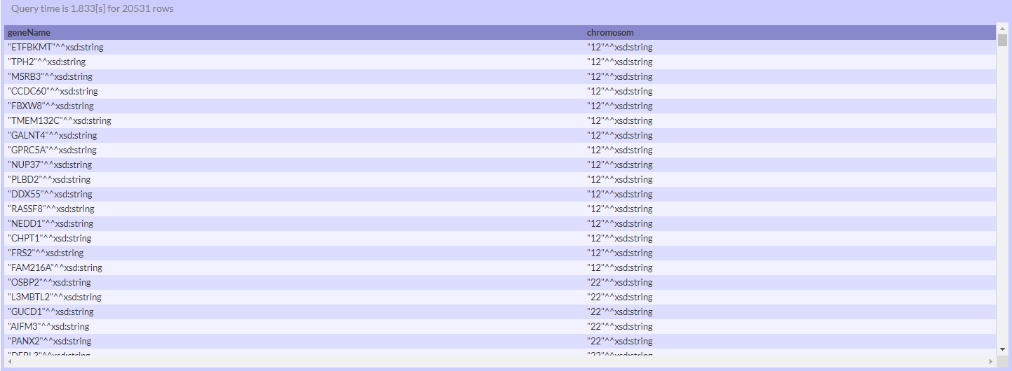

## Name of proteins whose genes are on chromosome 11

select ?entry where {

?entry :gene / :chromosome "11"^^xsd:string .

}

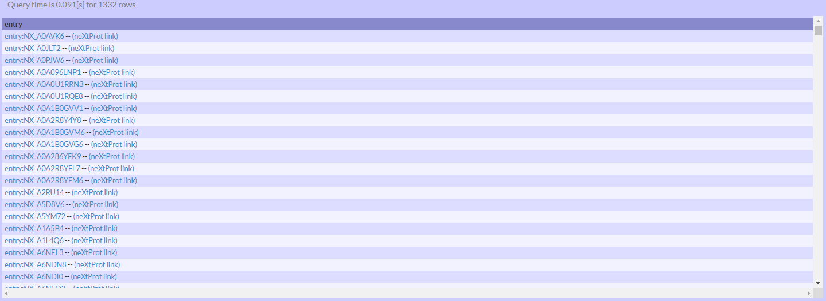

Task 2:

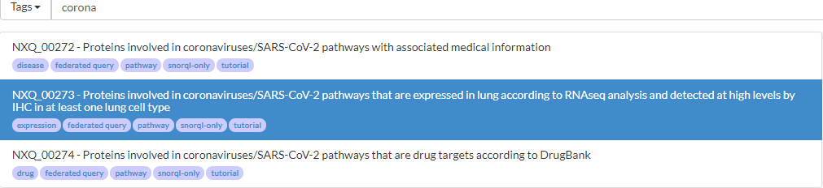

PREFIX wp: <http://vocabularies.wikipathways.org/wp#>

PREFIX rdfs: <http://www.w3.org/2000/01/rdf-schema#>

PREFIX dcterms: <http://purl.org/dc/terms/>

select distinct ?entry str(?gen) ?pathwayname group_concat(distinct str(?rnatissname), ',') as ?RNAseq_positive group_concat(distinct str(?ihctissname), ',') as ?IHC_high where {

service <http://sparql.wikipathways.org/sparql> {

{?geneProduct a wp:Protein}

union

{?geneProduct a wp:GeneProduct}

?geneProduct rdfs:label ?gen .

filter(!regex(?gen,"[ a-z-]")). # ensures official gene names for subsequent neXtprot matching

?geneProduct dcterms:isPartOf ?pathway .

?pathway a wp:Pathway .

?pathway wp:organism ?organism .

filter(contains(str(?organism),"9606"))

?pathway dc:title ?pathwayname .

filter(regex(?pathwayname,"sars-cov-2","i")|| regex(?pathwayname,"corona","i") ).

}

?entry a :Entry .

?entry :gene / :name ?gen .

?entry :isoform ?iso.

?iso :expression ?exprna, ?expihc.

?exprna :term ?rnatiss .

?exprna :evidence ?evirna.

?exprna :quality :GOLD .

?evirna :expressionLevel :Positive.

?evirna :evidenceCode cv:ECO_0000295. # RNA-seq

?rnatiss :childOf cv:TS-0568. #lung

?rnatiss rdfs:label ?rnatissname.

?expihc :quality :GOLD .

?expihc :term ?ihctiss .

?expihc :evidence ?eviihc.

?eviihc :evidenceCode cv:ECO_0001055. # Immunohistochemistry (IHC)

?eviihc :expressionLevel :High.

?ihctiss :childOf ?rnatiss .

?ihctiss rdfs:label ?ihctissname.

}

order by ?entry

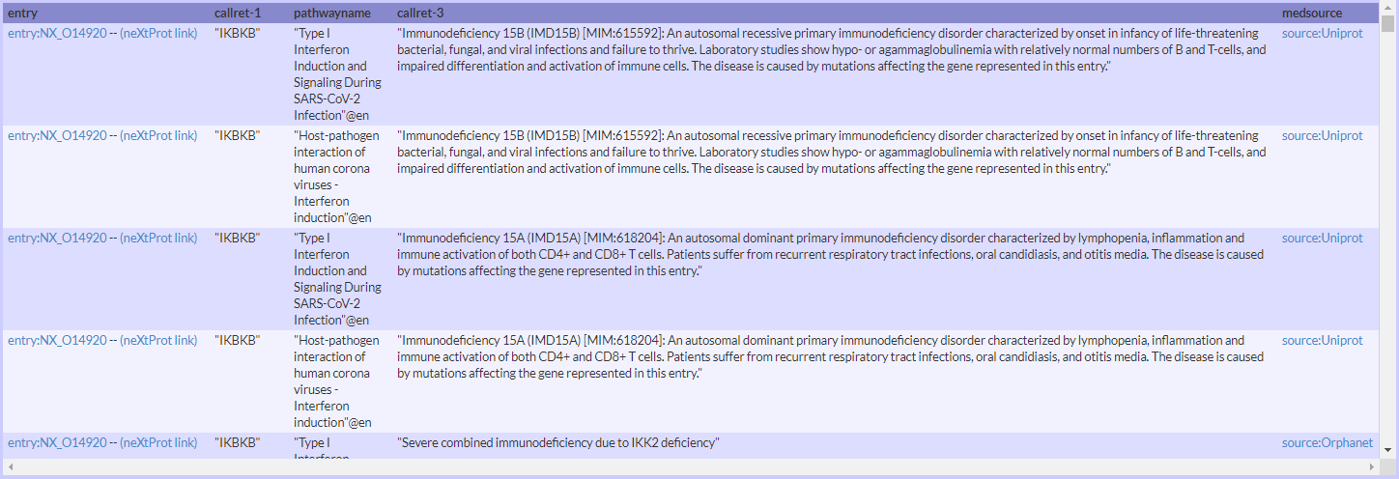

## Count of publication in 2019

SELECT DISTINCT Count(?public) WHERE {

?public :author ?author .

?public :year "2019"^^xsd:string .

}

